Republic of Tatarstan

Location: in the centre of the Russian Federation, in the East European Plain, at the confluence of the Volga River and the Kama River.

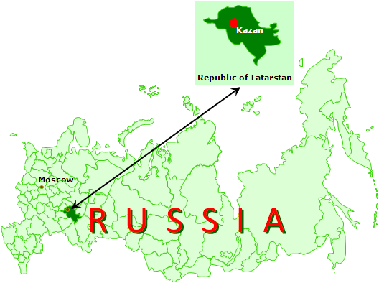
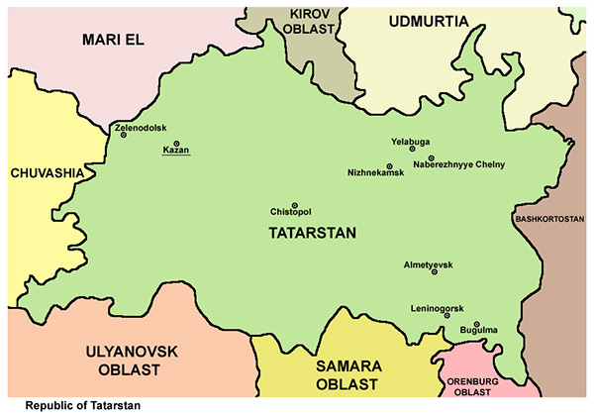

Total area: 67836.2 km2.

Capital: Kazan (797 km east of Moscow, population: 1,144,000).

Administrative territorial division: 43 municipal areas and 2 urban districts (Kazan and Naberezhnye Chelny).

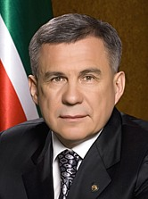
The head of the republic: President of the Republic of Tatarstan Minnikhanov Rustam Nurgalievich.

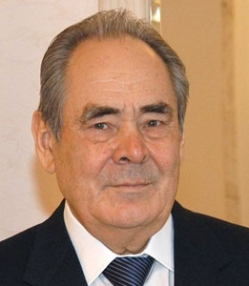

State Counsellor of the Republic of Tatarstan Mintimer Sharipovich Shaymiev

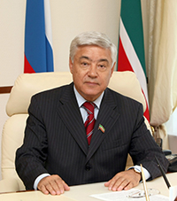
Parliament: State Council of the Republic of Tatarstan (unicameral), Chairman Mukhametshin Farid Khairullovich.

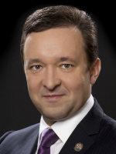
Government: Сabinet of Ministers of the Republic of Tatarstan, Prime Minister Khalikov Ildar Shafkatovich.

Population: 3,8 million people (2012), Tatars - 53.2%, Russians – 39.7% (2010 Census results).

Geographical Location

Tatarstan is situated in the Eastern part of the East European Plain at the confluence of two biggest rivers – the Volga and the Kama. Kazan is located 797 km far from Moscow.
The total area of the republic is 6783,7 thousand hectares. It spreads from North to South at 290 km and from West to East at 460 km from. Tatarstan has no borders with foreign states.
Tatarstan territory is a high stepped plain divided by dense network of river valleys. The plain is divided in three parts: the Pre-Volga, Pre-Kama and Trans-Kama areas.
The Pre-Volga region with maximum altitudes of 276 m occupies the northeastern part of the Volga Highland. The border lines of Mozhga and Sarapul highlands divided by Izh River Valley touch Eastern Pre-Kama region in the North. Maximum altitudes reach 243 m. Bugulma Highland located in Eastern Trans-Kama region is the highest in Tatarstan (381 m). The lowest relief is characteristic of the Western Trans-Kama region (up to 200 m).
17 per cent of the republic territory is covered with forests consisting of broad-leaved trees (oak, lime, birch, aspen). Pine wood is presented by pine and fir tree. 433 species of vertebrates and several thousand species of invertebrates inhabit Tatarstan territory.
The climate is moderate-continental with warm summer and cold-temperate winter. The warmest month is July with the average monthly temperature 18 – 20 °С, the coldest is January with the average monthly temperature -13 °С. Duration of warm period (with stable temperature above 0 °С) varies within 198-209 days, cold period - 156-167 days. Fallouts are spread rather regularly, the yearly amount makes 460 – 540 mm.
The soil varies from grey forest podsol in the Northern and Western parts to different kinds of black earth soil in the Southern part of the republic.
The Volga-Kama State Natural Biosphere Reserve and the National Park “Nizhnyaya Kama” are located on Tatarstan territory. The Volga-Kama State Natural Biosphere Reserve is located in Zelenodolsk and Laishevo municipal regions of the Republic of Tatarstan. Two detached areas of the reserve, Saralovsky (4170 hectares) and Raifa (5921 hectares), are located at a distance of about 100 km. The National Park “Nizhnyaya Kama” is located on the territory of Elabuga and Tukai municipal regions. There are several land and water tourist routes down the woodlands, and water routes down the water-storage basin, down the Kama and Kriusha rivers.

State

From 1990 the republic has adopted three crucial documents - the Declaration of State Sovereignty, the Constitution and the Treaty with the Russian Federation on Delimitation of Jurisdictional Subjects and Mutual Delegation of Powers. The three documents together form the basis for legal state, political stability of the society, economic reforms. On April 19, 2002, the State Council of Tatarstan adopted the revised version of the Constitution. The Constitution proclaims an individual, his rights and liberties the highest value and obliges the Republic of Tatarstan to accept, observe and protect human and civil rights and freedoms. The Tatarstan Constitution provides for such principles as universal suffrage, freedom of speech, freedom of conscience, right to participate in political parties and organizations, etc.
In accordance with the Tatarstan Constitution, from June 2000 the republic has the institution of the Commissioner for human rights in the Republic of Tatarstan. The post of Commissioner for the child rights in the Tatarstan Republic is founded in 2010.

The Tatarstan Constitution secures the division of legislative, executive and judicial powers.
The President is the head of state and highest official in Tatarstan. He heads the executive system of the republic and directs the Cabinet of Ministers - executive and administrative authority. The Cabinet is accountable to the President. The candidature of a Prime Minister is suggested by the President and approved by the Parliament of Tatarstan.
Unicameral State Council (Parliament) is the supreme representative and legislative authority of Tatarstan.
The bodies of local self-government are independent within their powers and do not belong to the system of state authorities.
The judicial power in Tatarstan is executed by the Constitutional Court, federal courts of general jurisdiction, the Arbitrary Court of the Republic of Tatarstan and justices of the peace. Judicial proceedings and records management are carried out in accordance with the federal legislation.

Economy

Tatarstan is one of the most economically developed regions in Russia. Republic is located in the center of large industrial region of the Russian Federation at the crossing of important highways connecting East and West, North and South of the country. The Republic of Tatarstan is rich in natural resources, powerful and diversified industry, high intellectual potential and qualified human resources.

2,2 % of Russia’s farmlands are used by the Republic of Tatarstan, 5% of the country’s agricultural produce are manufactured in republic.
The share of industry in the Tatarstan gross regional product is 44,1%, construction – 8,6%, transport and communications – 7,7%, agriculture – 7,1 %.
The industrial sector of republic is presented by the oil-gas-chemical complex (oil production, manufacturing of synthetic rubber, tyres, polyethylene, and wide range of oil refinery products), major engineering enterprises manufacturing competitive products (heavy trucks, helicopters, aircrafts, aircraft engines, compressors, oil-gas-pumping equipment, river and sea vessels, commercial and motor cars), development of electric and radio instrument engineering.
The share of small and medium-size business in gross regional product makes 25 %.

Technoparks are actively developing in the Republic of Tatarstan. ZAO “Innovative-production technopark “Idea”, industrial site KIP “Master”, IT-park, Technopolis “Himgard” are efficiently operating. The special economic zone of industrial-production type “Alabuga” was founded at the end of 2005. Currently there are 42 residents on its territory.
The following tax benefits are provided for residents of SEZ “Alabuga”:
• Reduced profit tax rate - 13,5 % instead of 20 %
• Exemption from transport tax during 10 years from the date of vehicle registration
• Exemption from property tax during 10 years from the date of property registration in accounting report
• Exemption from land tax during 10 years for land plots located on the territory of SEZ
• Higher depreciation charge can be used for taxation (i.e. standard depreciation charge must not exceed the standard rate twice)

Capital

The capital of the Republic of Tatarstan Kazan lies in the northwestern portion of Tatarstan along the banks of the Kazanka River at its confluence with the Volga River. It has a population of approximately 1,144,000.
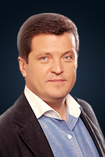

The Mayor of Kazan is Ilsur Metshin.

The capital of Tatarstan is a big railway, motorway and airway hub and one of the largest river ports on the Volga.
Metro opened in Kazan in 2005.
Main industries include machine engineering and metalwork, aircraft construction and instrument engineering, petrochemistry, textile and food processing.
Kazan manufactures helicopters (JSC Kazan Helicopters), aircrafts (KMPO, KAPO n.a. Gorbunov), compressor and refrigeration equipment (Kompressormash), polyethylene (Kazanorgsintez), synthetic rubbers (Kazan plant of synthetic rubber), medical (KMIZ) and optical instruments (KOMZ), detergents (Nefis-cosmetics) and drugs (Tatkhimfarmpreparaty). Most of the produce is made for export.
Kazan is also a large science and research center. Kazan Federal University, the second oldest university in the Russian Federation, was established in 1804. Kazan State Technological University and Kazan State Technical University have the status of national research universities. Altogether Kazan has 39 higher education establishments, the Tatarstan Academy of Sciences, the Kazan Scientific Centre of the Russian Academy of Sciences and several science and research institutions.
The Kazan Kremlin, the chief historic citadel of Kazan, was declared a World Heritage Site in 2000. The city boasts a registered brand of the "sports capital of Russia".
Kazan is proud of many outstanding people who lived and worked here including Nikolai Lobachevsky, Aleksandr Butlerov, Nikolai Zinin, Leo Tolstoy, Sergei Aksakov, Gavriil Derzhavin, Mikhail Balakirev, Mikhail Shchepkin, Vekimir Khlebnikov, Feodor Chaliapin, Nikolai Feshin, Vasily Kachalov and Peter Lesgaft.
The Tatar culture also has its prominent representatives who created their masterpieces in Kazan: Kayum Nasyri, Shigabutdin Mardzhani, Gabdulla Tukai, Musa Jalil, Salikh Saidashev, Farid Yarullin, etc.
Kazan is a multi-faith city with mosques, Orthodox churches, Lutheran and Catholic churches, a synagogue, a theological seminary and Russian Islamic University.
As Kazan is a city with fine cultural traditions, music lovers will find here Russia’s second in size concert hall, a philharmonic hall, an opera house, drama and puppet theatres, four state concerts, a dance and song ensemble, etc. Children and young people attend secondary and higher educational establishments of culture and arts.
Kazan hosts large international and national events such as the Feodor Chaliapin International Opera Festival, the Rudolf Nuriev International Classical Ballet Festival, the Europe-Asia Contemporary Music Festival, the Kazan International Muslim Film Festival. It staged the Nauruz International Theatre Festival of Turkic Peoples for several times. Cirque du Soleil came to Kazan twice.
The recent years have seen large-scale construction resulting in the new transport infrastructure and many new sport venues being put up. Kazan offers two water parks, Riviera being Russia’s largest and one of Europe’s biggest.
World Summer Universiade was held in the capital of the Republic of Tatarstan in 2013.
Kazan will also stage the FINA World Championships in 2015 and the World Cup matches in 2018.
Kazan was named the sports capital of Russia, following the national voting organized by the Russian Sports, Tourism and Youth Policy Ministry. In Russian, European and world competitions Kazan is represented by Ak Bars hockey club, Rubin-Kazan football club, Unics basketball club, Dinamo-Kazan bandy team, Zenit-Kazan volleyball club and others.
Kazan is one of top tourist destinations in the Russian Federation. 1 billion people visit Tatarstan capital every year.
The city where representatives of various faiths and ethnic backgrounds live in harmony and peace welcomes guests from around the world.

Symbols

At present, the use of the State Flag and the Coat of Arms of the Republic of Tatarstan as well as playing of the State Anthem of the Republic of Tatarstan are regulated by the Law about state symbols of the Republic of Tatarstan.

The National Flag of the Republic of Tatarstan
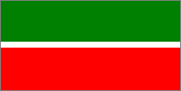

The national Flag of the Republic of Tatarstan represents rectangle cloth with horizontal strips of green, white and red colours. The white strip makes 1/15 width a flag and is located between equal in width the strips of green and red colours. A green strip is above.
The relation of width of a flag to its length - 1:2.
The author of The National Flag of the Republic of Tatarstan is T.G. Khaziakhmetov.

The State Emblem of the Republic of Tatarstan
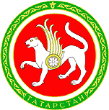
The State Emblem of the Republic of Tatarstan represents the image of a winged leopard with a round shield on one side, with the raised right forepaw on a background of a disk of the sun placed in a frame from the Tatar national ornament in which basis an inscription "Tatarstan", wings consist of seven feathers, the socket on a shield consists of eight petals.
In colour depiction of the State Emblem of the Republic of Tatarstan the sun is red, the leopard, his wings and the socket on a board are white, the frame is green, the shield, the ornament on the frame and the inscription "Tatarstan" are golden.
The authors of the State Emblem of the Republic of Tatarstan are N.G. Khanzafarov (idea), and R.Z. Fakhrutdinov (performance).

History

Volga Bulgaria was the first state formed in the region. It was created by Turkic tribes at the turn of 9 th-10th centuries. In 922 Islam became an official religion. In 1236 Bulgaria was merged into the Empire of Genghis Khan, after that it became a part of the Golden Horde and as a result of its dissolution a new state, the Kazan Khanate, emerged in 1438 and was incorporated to Russia in 1552.
In 1920 the Tatar Autonomous Soviet Socialist Republic was declared.
The Declaration on State Sovereignty of the republic was adopted on August 30, 1990. In 1994 the Treaty between the Russian Federation and the Republic of Tatarstan on Delimitation of the Jurisditional Subjects and Mutual Delegation of Powers between the State Bodies of the Russian Federation and the State Bodies of the Republic of Tatarstan was signed. It was followed by the Treaty on Delimitation of the Jurisdictional Subjects and Powers between the State Bodies of the Russian Federation and the State Bodies of the Republic of Tatarstan in 2007.

Culture
People with various historical and cultural traditions live in the republic. The combination of at least three types of cultural interaction (Turkic, Russian-Slavic and Finno-Ugric) defines the uniqueness of this area, the originality of cultural and historical values.
Destinies of many outstanding cultural workers are intertwined with Tatarstan: singer Feodor Chaliapin, writers Leo Tolstoy, Sergey Aksakov and Maxim Gorky, Vasily Aksenov, poets Evgeny Boratinsky, Gavriil Derzhavin, Marina Tsvetaeva and Nikita Zabolotsky, artists Ivan Shishkin and Nikolay Feshin. Such classics of Tatar poetry as Gabdulla Tukay, hero and poet Musa Jalil, composers Farid Yarullin, Salih Saidashev, Nazib Zhiganov, Sofia Gubaidulina and many others made the Tatar culture famous.

Religion
The traditional religions of the Republic of Tatarstan are Islam and Orthodox Christianity. Tatars and Bashkirs (i.e. nearly half of the population of the republic) confess Islam. The others, including Russians, Chuvashes, Maris, Udmurts, Mordovians – are Orthodox Christians. Catholicism, Protestantism, Judaism and other confessions are also presented in Tatarstan.
Keeping the balance of interests between the two major religions and equality of all religions before the law lies at the heart of inter-faith consent in the republic.

Education and science

Preschool, school and professional education
As for January 1, 2014, there are 1,958 pre-school educational organizations for 168,5 places working in the republic. 71.8 per cent of children aged 1-7 go to pre-school educational organizations. Moreover, there are 1431 schools with 361, 000 pupils.

Higher education
There are 27 higher educational organizations including 17 state and 10 non-state institutions in the Republic of Tatarstan. In addition, 49 branches of higher educational institutions, of which 27 are state and 22 non-state, are working in the republic. By and large, 180,000 people study at Tatarstan higher educational institutions.
Science
Tatarstan is also one of Russia`s scientific centers. The capital of the republic Kazan has the Academy of Sciences of Tatarstan, the Kazan Scientific Centre of the Russian Academy of Sciences. Tatarstan is involved in intensive fundamental and applied research activities in advanced scientific fields.
Scientific schools started to emerge in Kazan as early as in the 19th century. The Kazan chemical cchool is the most widely known; it was created under the direction of Nikolay Zinin, Alexander Butlerov, Alexander Zaytsev. The Kazan mathematics school was formed in the 19th century with Nikolay Lobachevsky being its brightest representative.

Innovations
Russia’s biggest special economic industrial zone Alabuga, 4 industrial parks, technopolis Himgrad, 14 technoparks operate in Tatarstan. The IT-Park was opened in 2009.
Tatarstan gives priority to the development of nanotechnological industry.

The Republic of Tatarstan is one of the leading sports regions in Russia.

Provision of facilities for sports activities, construction of sports venues in Tatarstan has laid the basis for formation of healthy lifestyle among various strata of the population.
There are 9175 sports venues in the republic. Almost all regions have modern sports complexes offering various kinds of sport. The total number of ice palaces now makes 35, and it is the best result in the country.
Involvement of the maximum number of citizens in physical culture and sport, provision of available and developed sports infrastructure, promotion of healthy lifestyle in society are priority activities aimed at development of physical culture and sport in republic.
Mass sport is extensively developing in republic. It has become the essential part of the educational system.
New forms of healthy lifestyle promotion and development of cultural and mass activity are used. Sports competitions among pupils, students, government and municipal employees, pensioners and disabled people are held.
The following events are organised every year: student Spartakiada of the Republic of Tatarstan; Championship of school basketball league among teams of the republican comprehensive institutions; republican rounds of All-Russia sport school competitions “Presidential competitions” and All-Russia sport games “Presidential sport games”; All-Russia football tournament “Leather ball”.
Moreover, annual mass sport competitions “Ski Track Russia”, “Ski Track Tatarstan”, “Cross of nations”, “Cross of Tatarstan” are held in republic.
The youth sports infrastructure is being improved as well. There are 250 youth institutions and 162 children’s and youth sports schools in the republic.
Much attention is paid to technical and extreme sports such as carting, parkour, skating, and rolling.
Realization of major international sport projects favours development of sport and urban infrastructure of the Kazan city, the capital of Tatarstan and the country’s biggest scientific-educational and student center.
The latest major sport events were: Russian Athletics Junior Championship, Russian football competitions among higher educational institutions of Volga federal district, Final of Russian Badminton Championship, XIX Grand Prix FINA Platform Diving Championship, Russian Weightlifting Championship, All-Russia Fencing Tournament, Final of Russian Volleyball Cup among youth teams, Russian Synchronous Swimming Championship, Final of Russian swimming cup, XII Championship of children’s and youth basketball league, Russian Junior Platform Diving Championship, Russian "Koresh" Belt wrestling competitions, Tatarstan open gymnastics cup.
The most significant event was the 27th World Summer Universiade 2013.
64 sports venues, 30 of which are newly constructed, were used during the Games.
The biggest objects constructed for the competitions are:
Football stadium for 45 000 seats;
Aquatics Palace;
Tennis Academy;
Ak Bars Wrestling Palace;
Saint Petersburg Volleyball Centre;
Boxing and table tennis center;
Rowing channel at the Middle Kaban Lake.
The Kazan Universiade was the most large-scale in the history of Student Games. 7980 athletes, 3798 officials from 160 countries, 2158 judges, 766 of which have international qualification, took part in the Games.
The Universiade programme included 27 sports. There were 351 set of medals.
Russian athletes took the first place in team classification, breaking all medal records of previous Universiades. By and large, Russian team won 292 medals, including 155 gold, 75 silver, and 62 bronze medals.
Tatarstan students made a considerable contribution to the victory of Russian team. Tatarstan athletes won 40 medals that makes 13.7 per cent of the total number of medals of the Russian team.
Victories of such famous teams as “Ak Bars”, “Rubin”, “UNICS”, “Zenit-Kazan”, “Sintez”, “KAMAZ-Master”,“Dinamo-Kazan” make an invaluable contribution to the sporting glory of Tatarstan.

